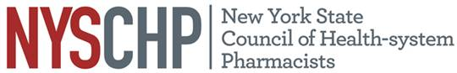
SOUTHERN TIER SOCIETY OF HEALTH-SYSTEM PHARMACISTS
Presents:
“Viral Disease: Monkeypox”
Speaker:
Alexandra Mirabile PharmD.
PGY-1 Resident Pharmacist
United Health Services Hospitals
On:
Tuesday, November 15th, 2022
5:30pm – 6:00pm: Registration
6:00pm – 6:30pm: Dinner
6:30pm – 7:30pm: Program
Location:
DeGennaro’s Restaurant
300 Hill Ave., Endicott
(607) 786-0000
Targeted Audience: Pharmacists, Pharmacy Technicians, Pharmacy Students
This is an open invitation for you to join us for this continuing education activity.
Fee:
Free for MEMBERS!
$10.00 for NON-MEMBER Pharmacists, Pharmacy Students and Pharmacy Technicians

RSVP no later than November 11th, 2022
Please Register Online: https://stshp.org/meetinginfo.php
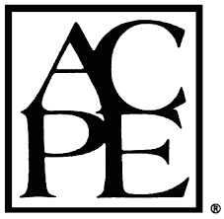
ACPE Statement of Accreditation: The NYS Council of Health-system Pharmacists is accredited by the Accreditation Council for Pharmacy Education as a provider of continuing pharmacy education. This program, 0134-0000-19-036-L01-P and 0134-0000-19-036-L01-T is approved for 0.1 CEU’s (1.0 contact hours). Statements of Continuing Pharmacy Education Credit are available online to participants upon the conclusion of the program. Participant must verify attendance at the meeting by entering the program CE code. Attendees have forty-five (45) days to evaluate the program and obtain their statements of credit.
Payments to NYSCHP are not deductible as charitable contributions for federal income tax purposes. However, they may be deductible under other provisions of the Internal Revenue Code (i.e., ordinary, necessary business expenses; miscellaneous itemized deduction).

